**Exercise 1 – Configuring a Basic Spring Application**

Steps:

1. Create a Maven Project named librarymanagement
2. Add spring core dependencies in the pom.xml file
3. Create and XML Configuration file named applicationContext.xml in the src/main/resources directory.
4. Define beans for the BookService and BookRepository in the XML file.
5. Create package com.library.service
6. Create package com.library.repository
7. Create a main class to load the spring context.

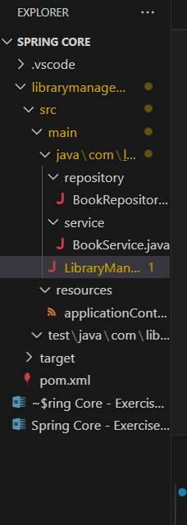

Place all the files in the repository accordingly

LibraryManagement/

├── src/

│ ├── main/

│ │ ├── java/

│ │ │ └── com/

│ │ │ └── library/

│ │ │ ├── LibraryManagementApplication.java

│ │ │ ├── service/

│ │ │ │ └── BookService.java

│ │ │ └── repository/

│ │ │ └── BookRepository.java

│ │ └── resources/

│ │ └── applicationContext.xml

├── pom.xml

**pom.xml dependencies**

<dependencies>

    <!-- Spring Core Dependency -->

    <dependency>

        <groupId>org.springframework</groupId>

        <artifactId>spring-core</artifactId>

        <version>5.3.10</version>

    </dependency>

    <!-- Spring Context Dependency -->

    <dependency>

        <groupId>org.springframework</groupId>

        <artifactId>spring-context</artifactId>

        <version>5.3.10</version>

    </dependency>

    <!-- Spring Beans Dependency -->

    <dependency>

        <groupId>org.springframework</groupId>

        <artifactId>spring-beans</artifactId>

        <version>5.3.10</version>

    </dependency>

</dependencies>

**applicationContext.xml**

<?xml version="1.0" encoding="UTF-8"?>

<beans xmlns="http://www.springframework.org/schema/beans"

       xmlns:xsi="http://www.w3.org/2001/XMLSchema-instance"

       xsi:schemaLocation="http://www.springframework.org/schema/beans

           http://www.springframework.org/schema/beans/spring-beans.xsd">

    <!-- Define BookRepository Bean -->

    <bean id="bookRepository" class="com.library.repository.BookRepository" />

    <!-- Define BookService Bean -->

    <bean id="bookService" class="com.library.service.BookService">

        <property name="bookRepository" ref="bookRepository"/>

    </bean>

</beans>

**LibraryManagementApplication.java**

package com.library;

import org.springframework.context.ApplicationContext;

import org.springframework.context.support.ClassPathXmlApplicationContext;

import com.library.service.BookService;

public class LibraryManagementApplication {

    public static void main(String[] args) {

        // Load Spring Context

        ApplicationContext context = new ClassPathXmlApplicationContext("applicationContext.xml");

        // Retrieve the BookService bean

        BookService bookService = (BookService) context.getBean("bookService");

        // Test the BookService

        System.out.println(bookService.getBookDetails(1));

    }

}

**BookRepository.java**

package com.library.repository;

public class BookRepository {

    public String findBookById(int bookId) {

        // For demonstration, return a hardcoded book detail

        return "Book details for book ID: " + bookId;

    }

}

**BookService.java**

package com.library.service;

import com.library.repository.BookRepository;

public class BookService {

    private BookRepository bookRepository;

    // Setter method for dependency injection

    public void setBookRepository(BookRepository bookRepository) {

        this.bookRepository = bookRepository;

    }

    // A sample method to get a book

    public String getBookDetails(int bookId) {

        return bookRepository.findBookById(bookId);

    }

}

Run the Application with Maven

